BUG REPORT OF CAR DEKHO
APP: CAR DEKHO
DEVICE : OPPOA37F
ANDROID VERSION : 5.1.1
APP VERSION: 7.0.9.4
DOWNLOAD SIZE : 8.94 MB
[PORTRAIT MODE]
1.MODULE/PATH : Homepage
BUG : In home page ‘d’ is missing at ahmedabad city.
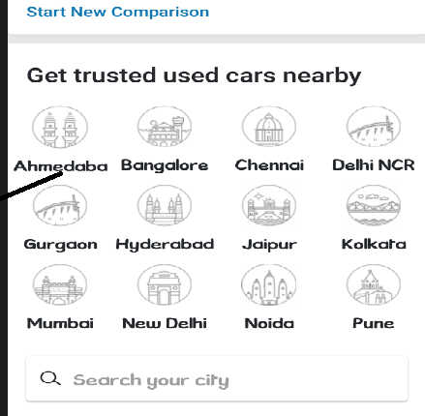
EXPECTED RESULT : Display should show “Ahmedabad”.
PRIORITY:Low
2.MODULE: Get personalized offers
BUG : Max length allow in name field.
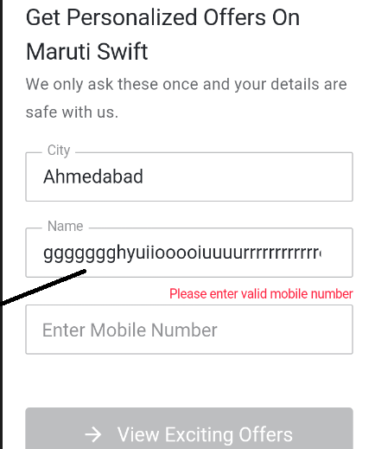
EXPECTED RESULT : Max length should not allow for name field.
PRIORITY : Medium
3.MODULE : FEEDBACK
BUG : In valid message allow in message field.

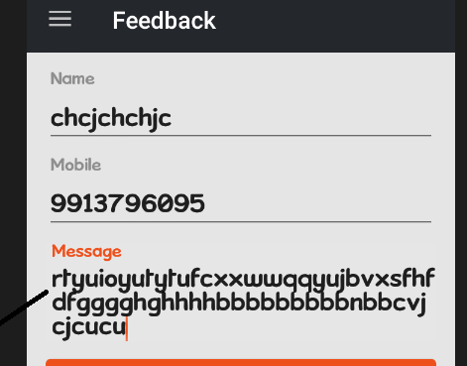
EXPECTED RESULT: Should allow valid massage.
PRIORITY: Medium
4.MODULE : Used car seller login
BUG: Valid email id does not valid.
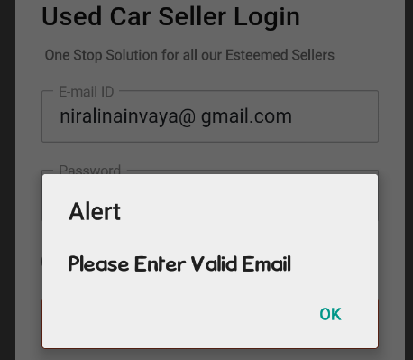
EXPECTED RESULT : Valid id should valid.
PRIORITY : High
5.MODULE: Used car seller login
BUG : Max length allow for password field.
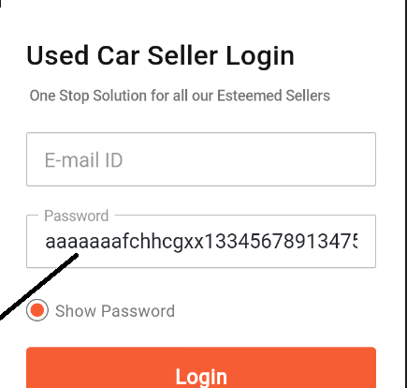
EXPECTED RESULT : Should not allow max length for password field.
PRIORITY : Low
6.MODULE : Search box
BUG : Search box is not working properly and does not allow trim.
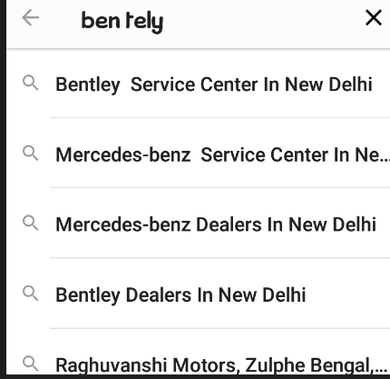
EXPECTED RESULT : Allow trim.
PRIORITY : Low
7.MODULE : INSURANCE
BUG: In year field show only 2 years.
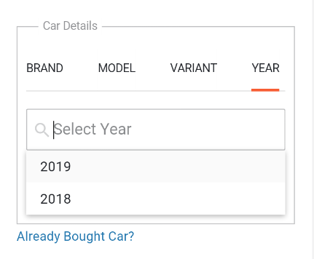
EXPECTED RESULT : Should show max years.
PRIORITY : High
8.MODULE : INSURANCE
BUG : In this field system show when we enter no in spouse then it allows children.
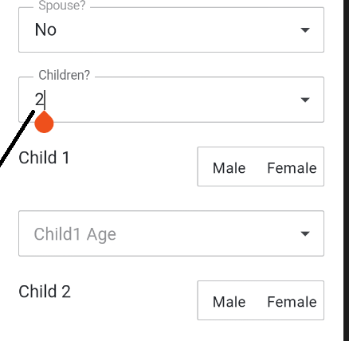
EXPECTED RESULT : Should not allow any value in children field.
PRIORITY :Hidh
9.MODULE: FAVOURITE
BUG : System not show favourite.
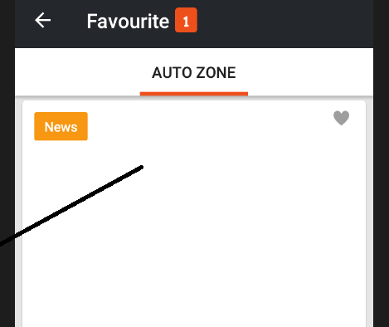
EXPECTED RESULT : Should show favourite.
PRIORITY : Medium
[SUGGESTIONS]
1.Design should not overlap.
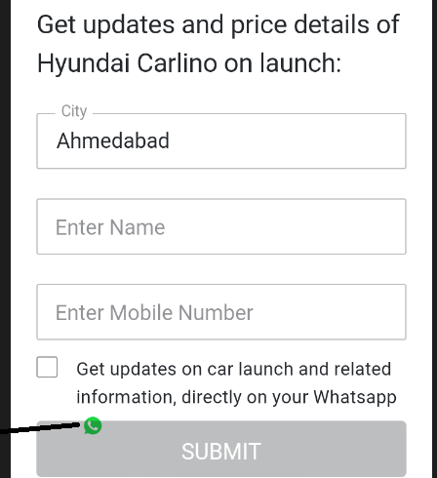
2.Logo should visible.
